SQL ASSIGNMENT – 3

#### 1) Write an SQL query to print the FIRST_NAME from Worker table after removing white spaces from the right side.

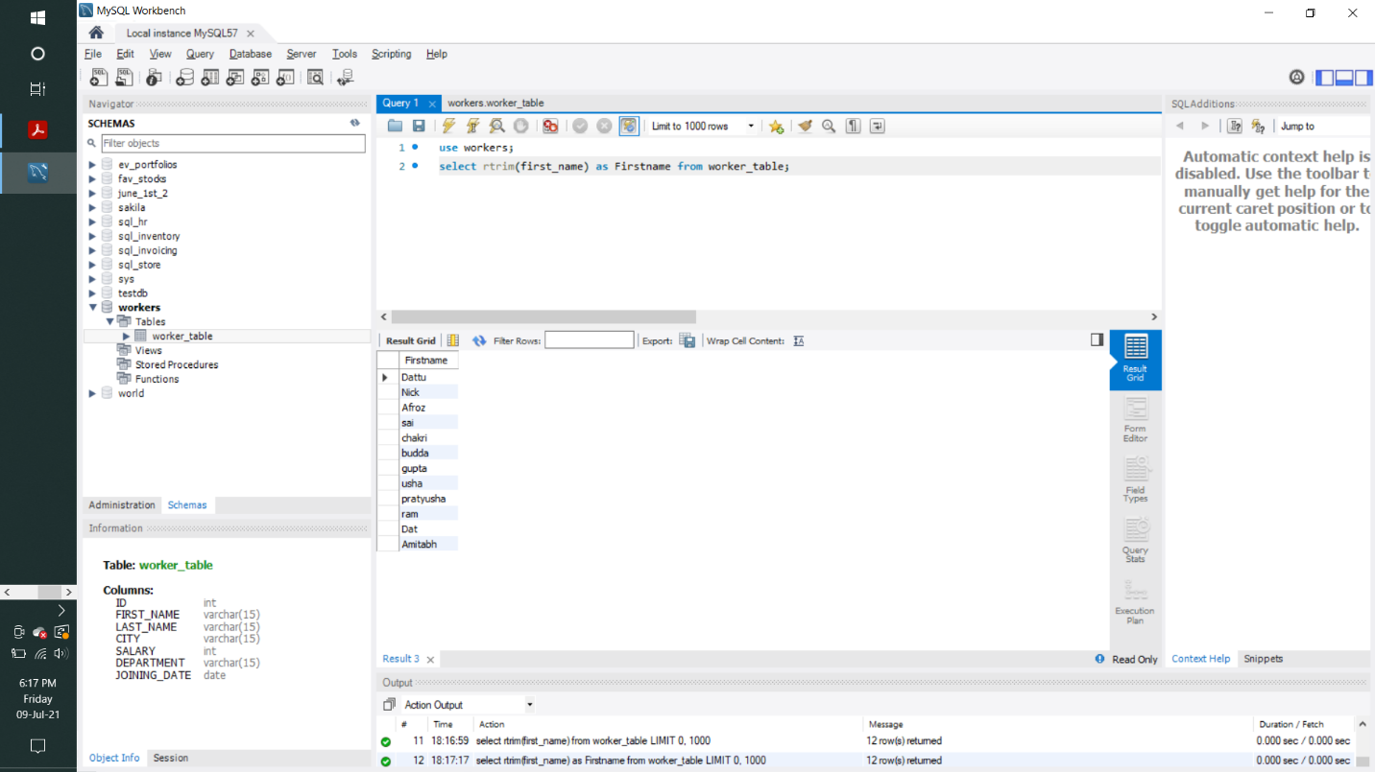

2) Write an SQL query that fetches the unique values of DEPARTMENT from Worker table and prints its length.

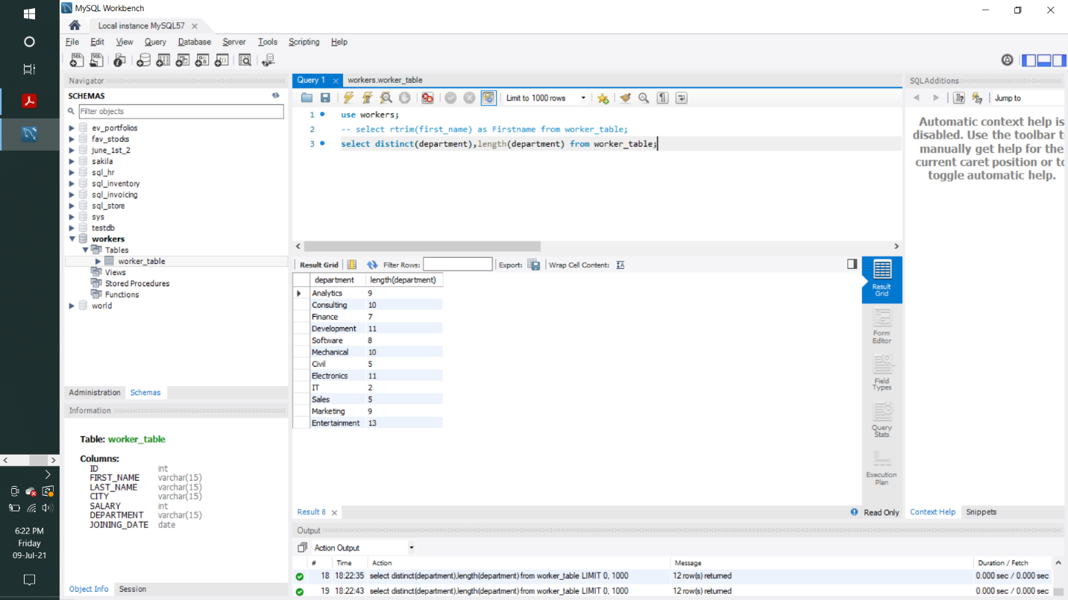

#### 3) Write an SQL query to fetch nth max salaries from a table.

